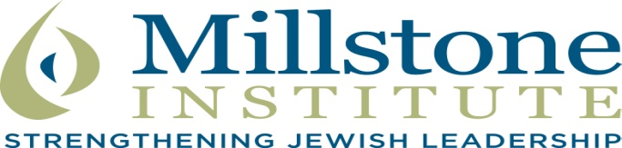
St. Louis Jewish Community

Jewish Federation Partner Agencies/Community Organizations
Covenant Place
Hillel at Washington University
Jewish Community Center (JCC)
Jewish Community Relations Council (JCRC)
Jewish Family & Children’s Service (JF&CS)
Jewish Federation of St. Louis
Jewish Light
MERS Goodwill (Careers in Transition)

Congregations
Agudas Israel
Bais Abraham
B’nai Amoona
Central Reform (CRC)
Kol Rinah
Nusach Hari B’nai Zion
Shaare Emeth
Shir Hadash
Temple Emanuel
Temple Israel
Traditional Congregation
T’pheres Israel (TICK)
U. City Shul
United Hebrew
Young Israel

Day Schools
Esther Miller Bais Yaacov (EMBY)
H.F. Epstein Hebrew Academy
Missouri Torah Institute (MTI)
Saul Mirowitz Jewish Community School
Torah Prep Schools (Boys, Girls)
Yeshivat Kadimah High School

Local offices of National/Int’l Organizations
Aish HaTorah
American Jewish Committee
Anti-Defamation League
Chabad
St. Louis/Show Me Chabad
Chesterfield
On Campus/Wash U./other campuses
Chinuch.org
Hadassah
Jewish Learning Experience at Wash U.
Hillel: Wash U, Maryville, Mizzou
Moishe House
National Council Jewish Women (NCJW)
Southern Illinois Jewish Federation
St. Louis Kollel
Torah Mitzion Kollel
Youth Groups – BBYO, JSU, NCSY, NFTY, USY

Independent Local Organizations
Crown Center for Senior Living
Cultural Leadership
Kabbalah Made Easy
Next Dor

Other
Ahavas Chesed Society
Barnes Jewish Chaplaincy
Jewish National Fund
Rabbinical Association
Rabbinical Council
Vaad Hoeir

