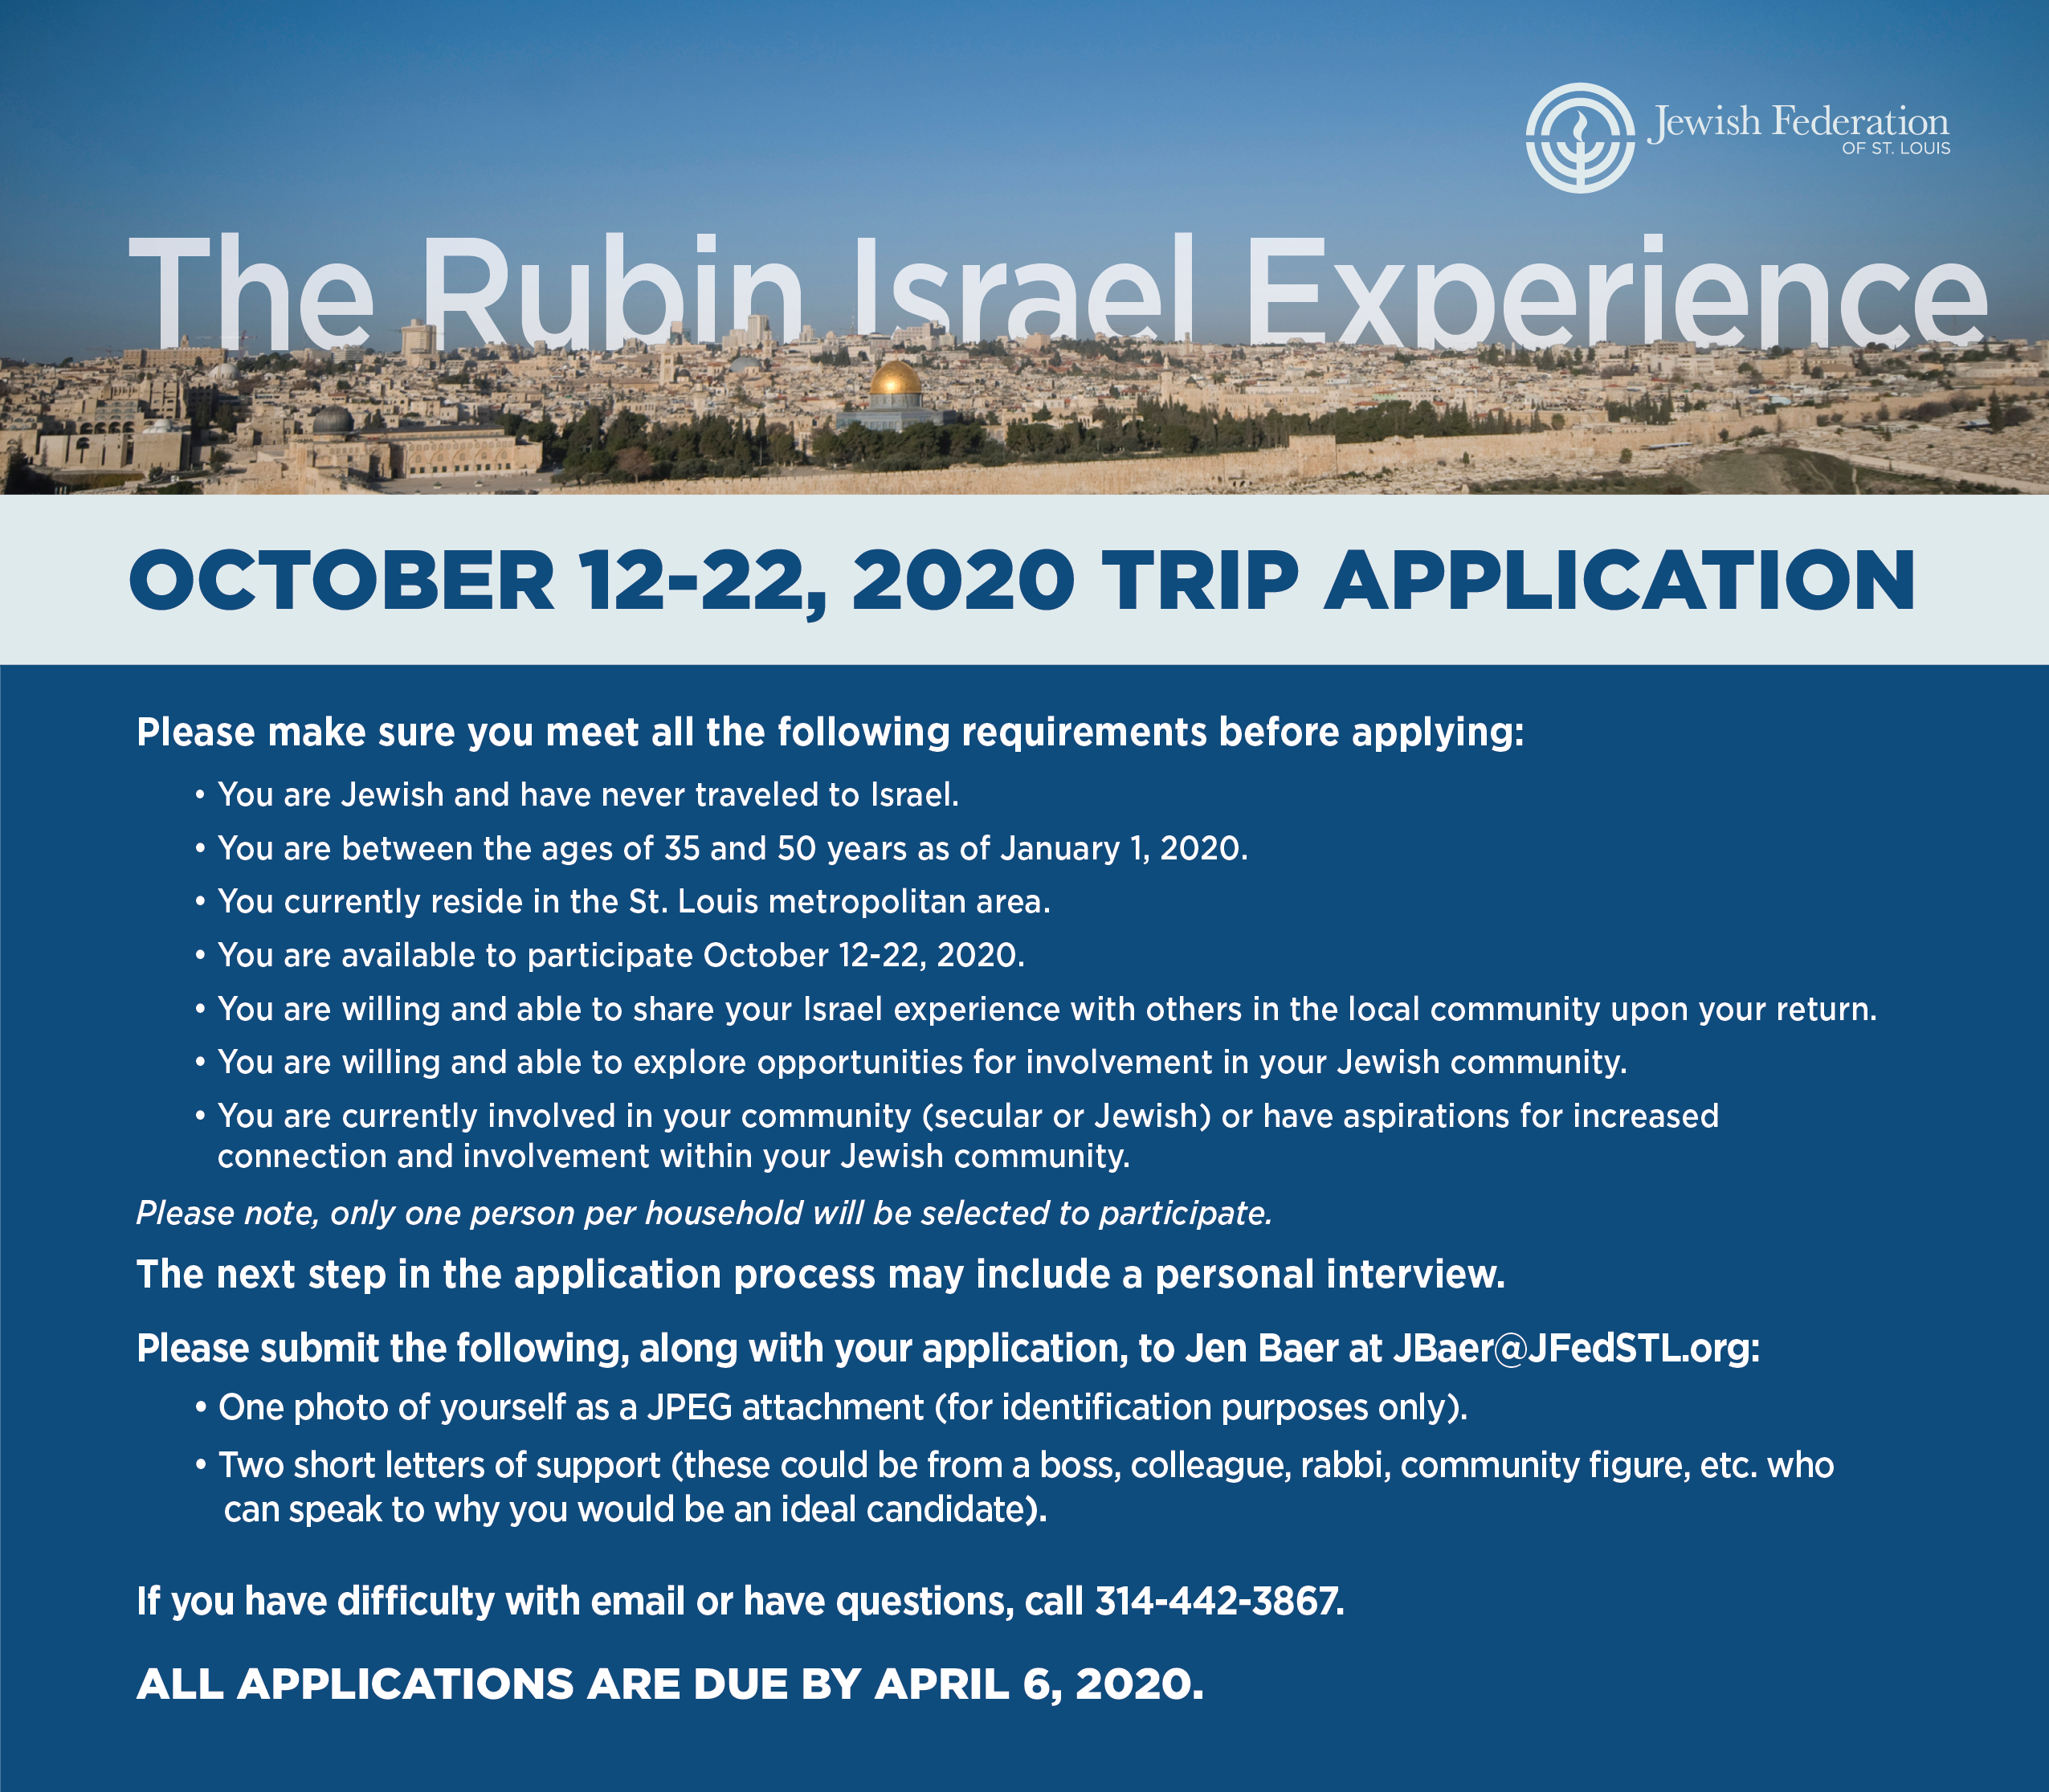

**Please type your response. Do not write in freehand.**

How did you hear about The Rubin Israel Experience?

Address (Work):

Company Name:

Occupation:

Phone Numbers:

Home:

Cell:

Work:

Congregation Affiliation, if any:

Address (Home):

Birthday (including year):

Age:

Name (Last, Middle, First):

Have you previously applied for this trip? (Yes/No)

We hope that your trip to Israel will inspire you to return full of pride, energy, and passion for involvement and connection within your Jewish community.

Although it is not a prerequisite for participating on this trip, please share your current involvement/positions you have in the community (civic, secular or Jewish) or what you are interested in pursuing:

**Short Essay Questions: (250 word maximum each)**

1. Please share a personal accomplishment in your life that you are most proud of and why.

2. What unique qualities would you contribute to the group if chosen to participate in this trip to Israel?

4. If chosen to participate in this Israel experience, on your return from Israel to St. Louis it is expected that you serve as an “ambassador” for your local and global Jewish community. Share with us some ideas you have as to how you might best serve as an “ambassador.”

3. Why are you interested in traveling to Israel at this time, and what do you expect to gain from the experience?